Game Design Document - Fireball! (Working Title)

Designers: Glittika Gerdmanee (Nancy), Douglas Tilden (Richard)  
Artists: Tirana Kilmister, Wing Him Choi

Programmer: Finn Perry

**One-Sentence Pitch** **1**

**Overview** **1**

**Product Details** **1**

**Key Features** **1**

**Core Experiences** **1**

**Gameplay Details** **2**

**Art Style** **4**

**Audio Direction** **7**

**Level Plans** **7**

**Iteration History** **8**

Initial Design 8

# 

# One-Sentence Pitch

Battle against your friends in the Baby Dragons’ Playgrounds as you Fireball critters for the highest score in this action-packed party game!

# Overview

**Fireball!** is a casual party game where players play as dragons to shoot various fireball bombs to incinerate randomly spawned critters. The main goal is to gain the highest score through incinerating spawned critters or other players.

# Product Details

**Fireball!** is a 3D top down action party game for the PC, targeted towards casual gamers. The game contains various stages with different hazards and dragons as main characters. Power-ups can also be gained to enhance gameplay experience.

The game is a premium single purchase on digital distribution platforms such as Steam, GOG, Itch Io etc.

# Key Features

* **Cute Colourful Dragons** - Players can choose from a variety of dragons to play as and differentiate themselves from others
* **Trove of Power-Ups** - Players can get an edge over their opponents by collecting and using power-ups.
* **Multiple Arenas** - Compete in a variety of environments, each presenting their own challenges and obstacles to overcome.

# Core Experiences

* **Fast-paced Competitive Action** - Destroy more creatures than other players, competing to get the most points before time runs out!
* **Enter a Cute and Colourful World** - Play as adorable baby dragons incinerating cute, helpless critters in bright and colourful arenas.
* **Master a Variety of Arenas** - Each arena presents a unique environment for players to experience, each with its own challenges, obstacles and power-ups.

# Gameplay Details

**Overview of Play**

Players individually compete against other players in a rectangular arena and attack randomly spawned critters, or other players, to gain the highest score possible before the timer runs out. When a player is hit 3 times, they will be immobile for a few seconds. Players choose different coloured dragons- as well as different arenas to compete in. Upon incineration, critters can also randomly give players different power-ups to use and get ahead of other players. A player wins if they have the highest score once the timer runs out.

**Mechanics**

* **Movement** - players can move around the arena in all directions. They can also dodge across short distances and jump, to navigate the environment and dodge attacks.
* **Health Bar** - A 3-hit health system that will render the player immobile and invincible for a few seconds
* **Gag Achievements** - based on certain actions, players may receive a humorous title during the victory screen
* **Fire Attacks** - a limited range projectile to incinerate critters and other players
* **High Score System** - points added per critter or player incinerated, receiving more points if a player is eliminated
* **Power-ups** - a variety of power-ups can be randomly gained through incinerating critters, such as:
  + Projectile Cone - grants a wider attack range for a few seconds
  + Freeze - single use, temporary stop another player for a few seconds
  + Bomb - single use, allows for an explosion of a bigger radius - including the player who placed it down if in range
  + Speed Up - increases player movement for a few seconds

**Rules**

1. Choose your dragon
2. Select an arena manually or by a randomizer to play in
3. Spawn in the arena corners and the game starts
   1. Critters spawn and the countdown timer begins
4. Shoot out your fire attack to incinerate critters and gain points
   1. Gain bonus point when you incinerate other players
   2. Critters themselves have a chance of dropping power-ups when incinerated
5. When the timer runs out, the game ends and the player with the most points win
   1. Players may gain humorous gag titles based on certain actions they perform during the game (e.g. most times frozen)

**Gameplay Loops**

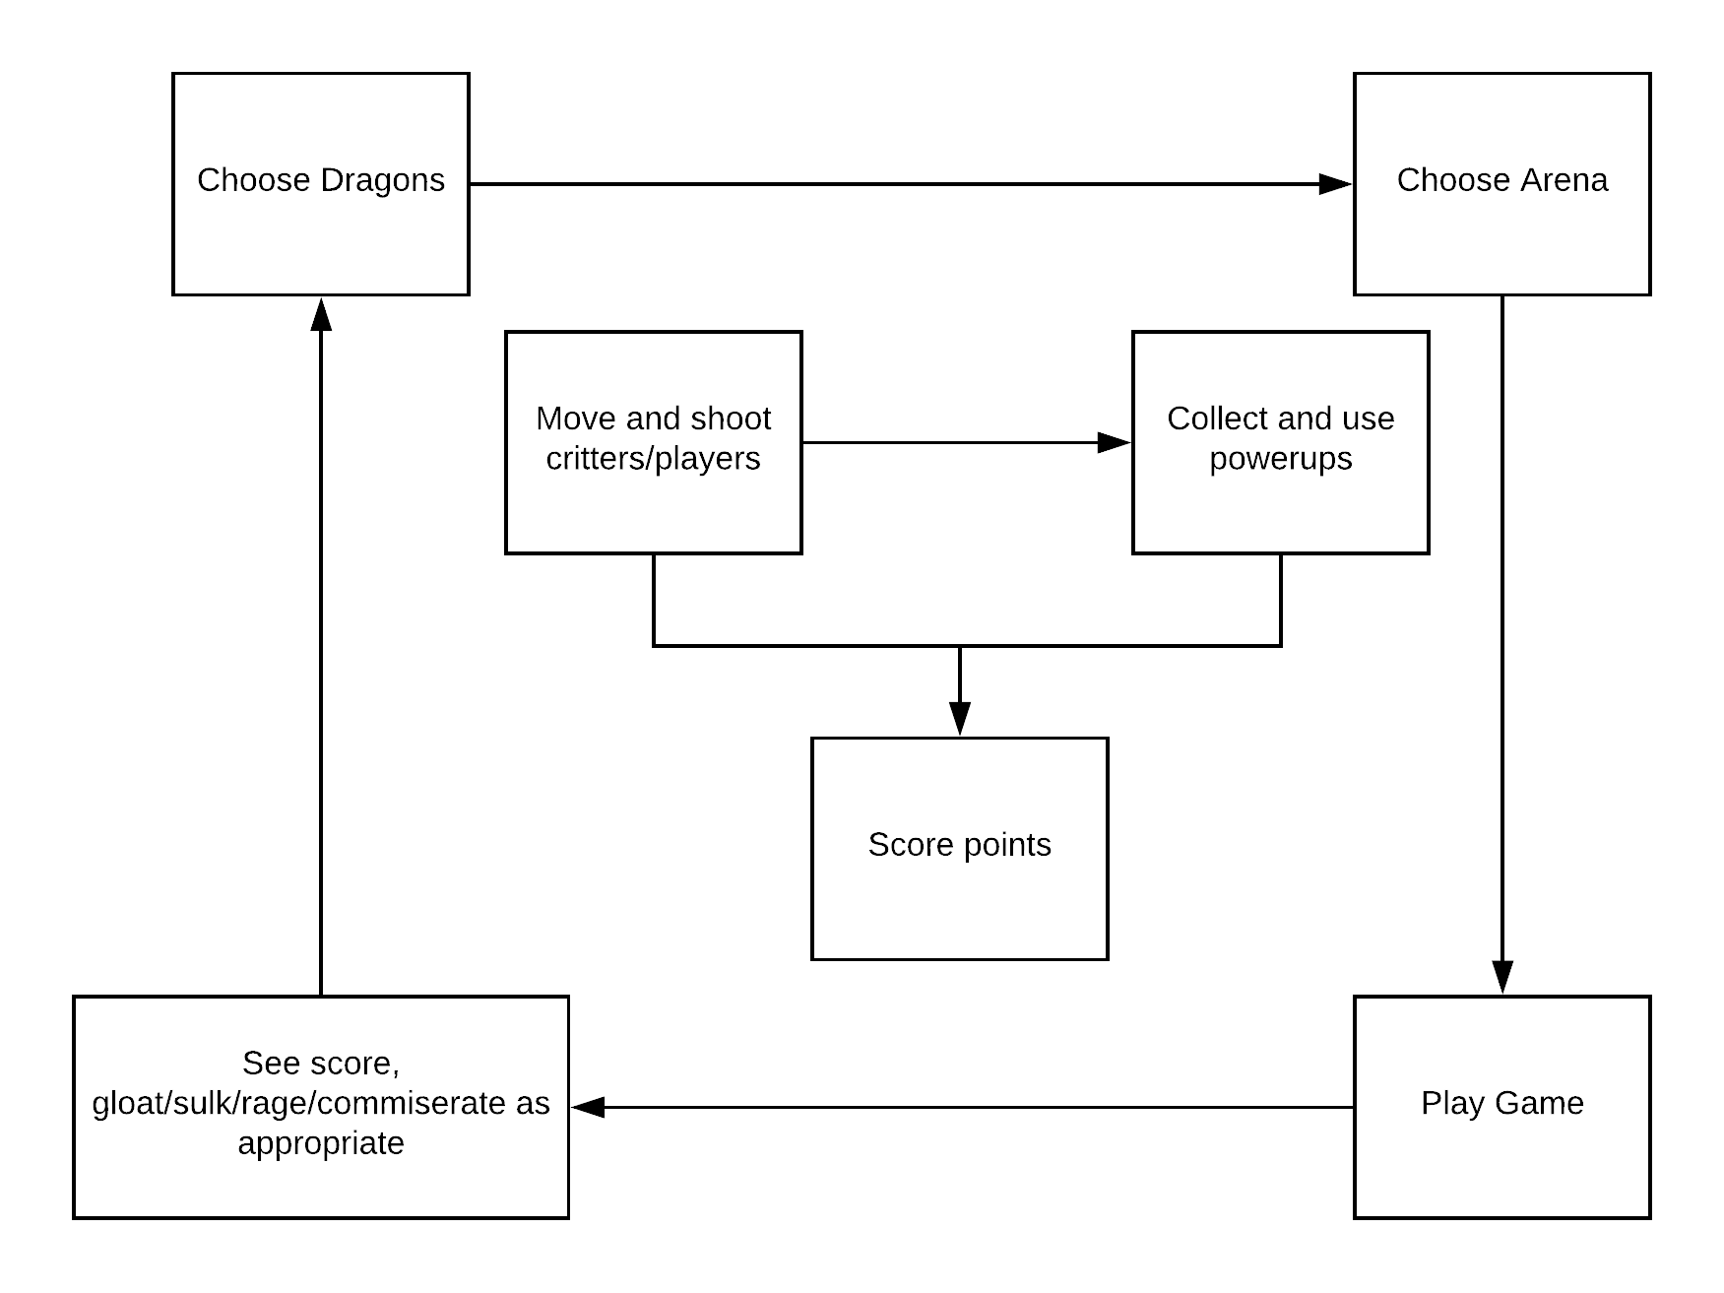

# 

# 

# Art Style

* Cute - baby dragons
* Lots of colour
* 3D Cartoony, toon-styled

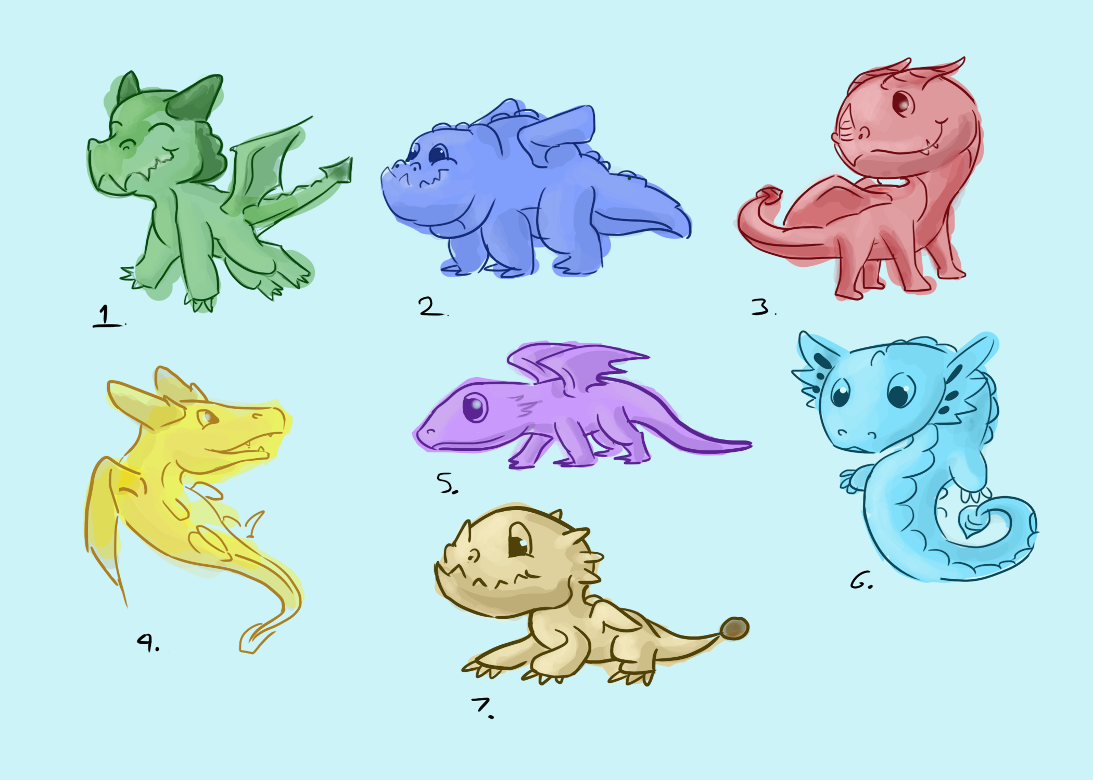

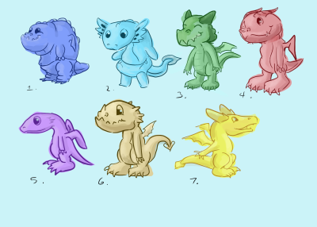

Figure 1 & 2: Dragon Concepts

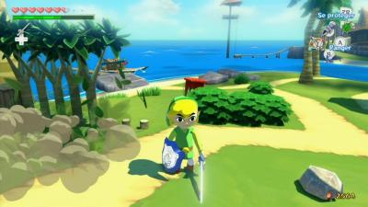

Figure 3: A reference for the cartoony, 3D art style

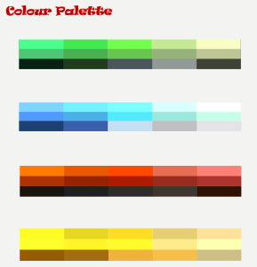

Figure 4: Colour Palettes

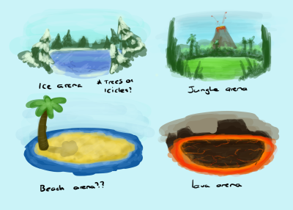

Figure 5: Initial Arena Concepts

# 

# Audio Direction

* Cute sound effects
  + Dragons communicate emotion through baby-ish noises, roars and squeals
  + Critters squeak
  + Cartoony tone
* Original background music
* Fireball shooting sounds

# Level Plans

Flat open arenas with varying themes, allowing free roam for players. Arena is enclosed around a barrier based on the environmental (e.g. wooden fences, stone walls etc…) surroundings

The open field is where players incinerate critters and fight each other, as well as gain power-ups.

**Forest Arena (Main focus)**

* Greenrys, somewhat tropical
* Rock pillars, bushes, trees
* Standard level - no (extreme) obstacles
* Rabbit critters

**Ice Arena**

* Blue hues, clean and pure
* Snowy trees, icy floor, snow
* Icy slippery floor - affecting player movement
* Penguin critters

**Lava Arena**

* Fiery atmosphere
* Bouldered, lava rocks
* Erupted lava and lava rocks fall from sky
* Lava lizard critters

**Beach Arena**

* Warm colours, tropical island
* Sand, trees, ocean
* Incoming waves can enter arena - bringing in more critters and disrupt movement
* Crab critters

# Iteration History

## Initial Design

* Destructive terrain
* Main goals of game being separated into game modes
  + Reaching a certain score first
  + Reaching highest score before timer runs out
  + Teams (2v2) try to eliminate each other’s health bars to zero
* Bombs being the *main* attack mechanic